Advanced SQL
Exercise 1: Created a Stored Procedure
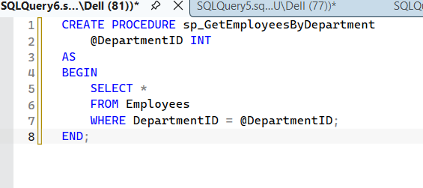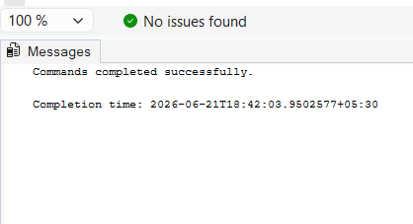
- Insert Employee In stored procedure
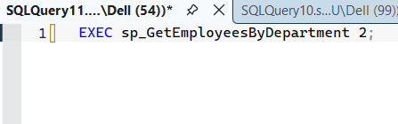
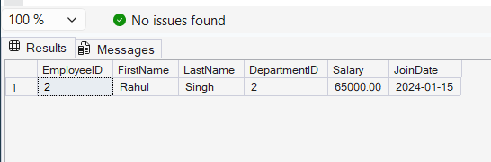

- Retrieve Employees by Department Procedure
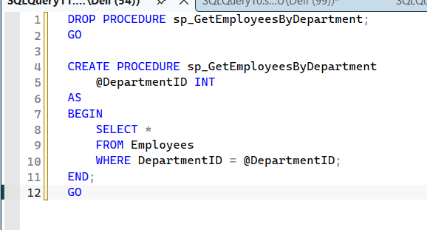
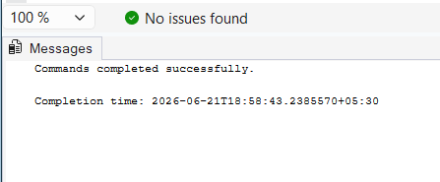
- Define the stored procedure with a parameter for DepartmentID.
A stored procedure is a precompiled collection of SQL statements that can be executed repeatedly. Parameters are used to pass values to the stored procedure at runtime.
In this exercise, the parameter @DepartmentID is used to retrieve employees belonging to a specific department. The procedure accepts a department ID as input and returns only the employee records matching that department.

